
INSTITUTE OF TECHNOLOGY BLANCHARDSTOWN

NATIONAL DIPLOMA IN COMPUTING
(Information Technology)

Object Orientation with Design Patterns

CM302

Semester I

Internal Examiner(s): Ms. Orla McMahon

External Examiner(s): Mr John Dunnion
Prof. Gerard Parr

August 2004
Time of examination here

Instructions to candidates:

- Section A: Attempt any five parts.
- Section B: Answer any 3 Questions.
- All questions carry equal marks.

DO NOT TURN OVER THIS PAGE UNTIL YOU ARE TOLD TO DO SO

Section A
Attempt any 5 parts of this question (5 marks each)

a) | Describe the difference between Class Adapters and Object Adapters.  [5 Marks]
b) | Graphical representations of design patterns only capture the end product of the design process.  Why?  List and briefly describe four essential elements that can be used to describe a design pattern.  [5 Marks]
c) | Any object in Java can be queried to see what methods and parameters make up its interface.  Write a code sample that demonstrates how you would query a Java object for its methods only.  [5 Marks]
d) | Describe with the aid of a code sample how you can easily determine that you are dealing with two identical instances of a Flyweight class.  [5 Marks]
e) | Briefly describe the difference between the Factory Method Pattern and the Abstract Factory Pattern.  [5 Marks]
f) | Briefly describe the Template Pattern and the four types of methods that can be found in a template class.  [5 Marks]
g) | What is a “Design Pattern”?  What are the advantages of using Design Patterns?  [5 Marks]

(25 marks)

Section B
Candidates should attempt any 3 of the following questions.

Question 2

2a) | What are Creational Patterns?  Name four.  [6 Marks]
2b) | What is the Singleton Pattern and when would you use it?  Write a simple Singleton Class that uses exception handling to force the programmer to deal with the possibility of null pointers.  [8 Marks]
2c) | The following UML class diagram describes a Simple Factory Pattern that is used to create two different kinds of NumberList objects based on a value passed to the getNumberList method.  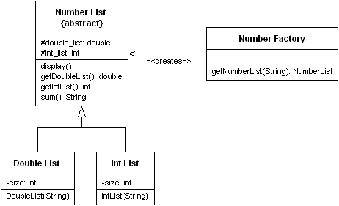  Using the following test code as a reference, implement each of the classes shown in the UML class diagram above.  String list1 = new String("1 2 3 4 5 6 7 8 9 10");  String list2 = new String("1.1 2.2 3.3 4.4 5.5 6.6  7.7 8.8 9.9 10.1");  NumberFactory nfactory = new NumberFactory();  nfactory.getNumberList(list1).display();  NumberList numberlist2 =  nfactory.getNumberList(list2);  numberlist2.display();  System.out.println("Sum of list 2 : " +  numberlist2.sum());  [11 Marks]

(25 marks)

Question 3

3a) | The Chain of Responsibility Pattern helps to keep separate the knowledge of what each object in a program can do. That is it reduces the coupling between objects so that they can act independently.  Describe four situations where this pattern might be used.  [4 Marks]
3b) | The program given in code listing 1 (on next page) creates a simple user interface that allows the user to select menu items, File|Open and File|Exit, and click on a button labelled Blue that turns the background of the window blue.  As long as there are only a few menu items and buttons this approach works fine, but when there are several menu items and buttons the actionPerformed code can get pretty unwieldy.  Using a simple Command Pattern re-write the appropriate sections of this program so that the conditional block in the actionPerformed code is removed.  [10 Marks]
3c) | Write a program that allows the user to add items to a JList control by typing text into a JTextField and clicking on an add button. Your program should take advantage of the Model View Controller (MVC) architecture.  In developing your program you must incorporate the following classes  - MainWindow extends JFrame  - ListData extends AbstractListModel  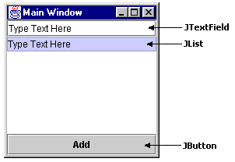  [11 Marks]

(25 marks)

Code Listing 1

public class SimpleApp extends Frame implements ActionListener
{
Menu mnuFile;
MenuItem mnuOpen, mnuExit;
Button btnBlue;
Panel p;

public SimpleApp()
{
super("Simple App");

//Create a new menu bar for the frame
MenuBar mbar = new MenuBar();
setMenuBar(mbar);

// Create the menu items and add them to the bar
mnuFile = new Menu("File", true);
mbar.add(mnuFile);
mnuOpen = new MenuItem("Open...");
mnuFile.add(mnuOpen);
mnuExit = new MenuItem("Exit");
mnuFile.add(mnuExit);

// Add an actionlistener for each menu item
// actions will be handled by this class
mnuOpen.addActionListener(this);
mnuExit.addActionListener(this);

// Create a button for the frame
btnBlue = new Button("Blue");

// Create a panel and add the button
p = new Panel();
add(p);
p.add(btnBlue);

// Add an actionlistener for the button
// actions will be handled by this class
btnBlue.addActionListener(this);

setBounds(100,100,200,100);
setVisible(true);
}

// Handle actions from the menu items and button
public void actionPerformed(ActionEvent e)
{
// Determine the source of the action and
// carry out the appropriate action
Object obj = e.getSource();
if(obj == mnuOpen)
fileOpen();
if (obj == mnuExit)
exitClicked();
if (obj == btnBlue)
redClicked();
}

// Called from actionPerformed when exit selected
private void exitClicked()
{
System.exit(0);
}
// Called from actionPerformed when Open selected
private void fileOpen()
{
FileDialog fDlg = new FileDialog(this, "Open a
file",FileDialog.LOAD);
fDlg.show();
}
// Called from actionPerformed when button clicked
private void redClicked()
{
p.setBackground(Color.blue);
}

static public void main(String argv[])
{
new SimpleApp();
}
}

Question 4

4a) | Define the terms Observer and Subject with regard to the Observer Pattern.  Write an abstract class called Observer and an abstract class called Subject that could be used to implement the Observer Pattern.  [6 Marks]
4b) | The following UML class diagram describes a commonly used creational pattern. Name the pattern and describe how each of the classes in the diagram contributes to the patterns implementation.  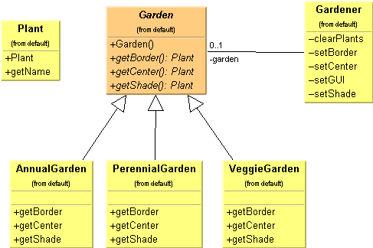  [8 Marks]

4c) | The Iterator Pattern is one of the simplest and most frequently used of the design patterns.  Java supports the Iterator pattern by providing Enumerations for its Vector and Hashtable classes.  Given a Vector containing a list of names, write a class which implements the Enumeration interface so as to provide a filter that will only iterate through names that begin with some prefix.  So, for example, a test program for the Filter class might look as follows:  class MainApp  {  private Vector data;  public MainApp()  {  data = new Vector();  data.addElement("Alan");  data.addElement("Conor");  data.addElement("Joanne");  data.addElement("David");  data.addElement("John");  data.addElement("Martin");  }  public void filterNames()  {  Filter filter = new Filter(data.elements(), "Jo");  while(filter.hasMoreElements())  {  String s = (String)filter.nextElement();  System.out.println(s);  }  }  public static void main(String[] args)  {  MainApp app = new MainApp();  app.filterNames();  }  }  [11 Marks]

(25 marks)

Question 5

5a) | Compare the intent of the Facade and Adapter design patterns.  [6 Marks]
5b) | Use an intuitive example to explain the intent of the Composite design pattern.  [6 Marks]
5c) | Examine the classes in code listing 2 (on next page), then answer the following questions:  - Create a new Decorator class called CrazyDecorator.  The CrazyDecorator class must change a JComponent’s background colour to red when the mouse enters the JComponent.  The JComponent’s background colour must be reset to it’s original colour when the mouse exits the JComponent.  [9 Marks]  - Create a simple test program call DecoratorTester which will decorate a JButton with the SlashDecorator AND the CrazyDecorator.  [4 Marks]

(25 marks)
Code Listing 2

Decorater.java

public class Decorator extends JComponent
{
public Decorator(JComponent c)
{
setLayout(new BorderLayout());
add("Center", c);
}
}

SlashDecorator.java

import java.awt.*;
import java.awt.event.*;
import javax.swing.text.*;
import javax.swing.*;
import javax.swing.event.*;
import javax.swing.border.*;

public class SlashDecorator extends Decorator {
int x1, y1, w1, h1;

public SlashDecorator(JComponent c) {
super(c);
}
public void setBounds(int x, int y, int w, int h) {
x1 = x; y1= y;
w1 = w; h1 = h;
super.setBounds(x, y, w, h);
}
public void paint(Graphics g) {
super.paint(g);
g.setColor(Color.red);
g.drawLine(0, 0, w1, h1);
}
}

